ASSIGNMENT 2 (WEB MERKETING)

1.Targeting external customers



Targeting external clients External communication goes far beyond advertising. According to the searched objectives, the organization targets its external customers by selecting the most appropriate media.

2. Targeting discount customers.



With personalized discounts, businesses can offer their customers more than can deliver a deal specifically targeted to a customer's interests.

3. Targeting discretionary customers

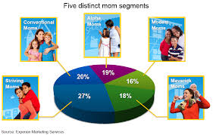

Consumer discretionary is the term given to goods and services that are considered non-essential by consumers, but desirable if their available income is sufficient to purchase them. Consumer discretionary goods include durable goods, apparel, entertainment and leisure, and automobiles.

4. Targeting need-based customers



Need Based Customers- These customers are product specific and only tend to buy items only to which they are habitual or have a specific need for them. They investigate features of most prominent products in the market but do not buy any of those or show least interest in buying.

5. Targeting seasonal customers



 Seasonal marketing is marketing products or services at certain points of the year. That could be Christmas, Easter or Thanksgiving, but seasonal marketing doesn't have to coincide with an 'official' event.

6. Using safety as level of need

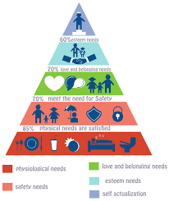

Safety and security needs are about keeping us safe from harm. These needs include shelter, job security, health, and safe environments. If a person does not feel safe in an environment, they will seek to find safety before they attempt to meet any higher level needs.

7. Using belongingness as level of need



 Belongingness is the human emotional need to be an accepted member of a group. Whether it is family, friends, co-workers, a religion, or something else, people tend to have an 'inherent' desire to belong and be an important part of something greater than themselves.

8. Using Ego as level of need



Ego needs or we can say esteem needs consists of self confidence and self respect. When the physiological, safety and social needs are satisfied then people start demanding respect for themselves in a group.

9. Using the cool factor



Cool has been used to describe a general state of well-being, a transcendent, internal state of peace and serenity. It can also refer to an absence of conflict, a state of harmony and balance, as in "The land is cool", or as in a "cool [spiritual] heart". Such meanings, according to Thompson, are African in origin.

10. Making reference to a reference group

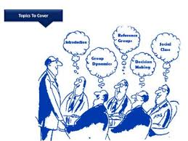

A general conceptual framework that assumes that individuals' attitudes, values, and self-appraisals are shaped, in part, by their identification with, and comparison to, referencegroups.